Metro Station Project- Architectural & Structural BIM
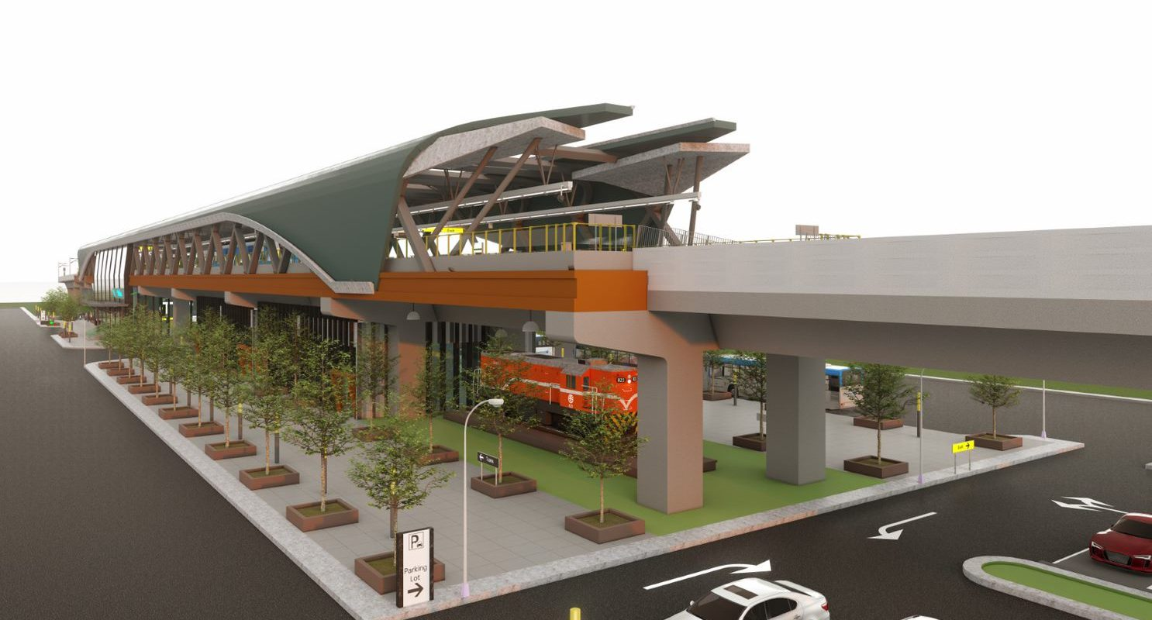
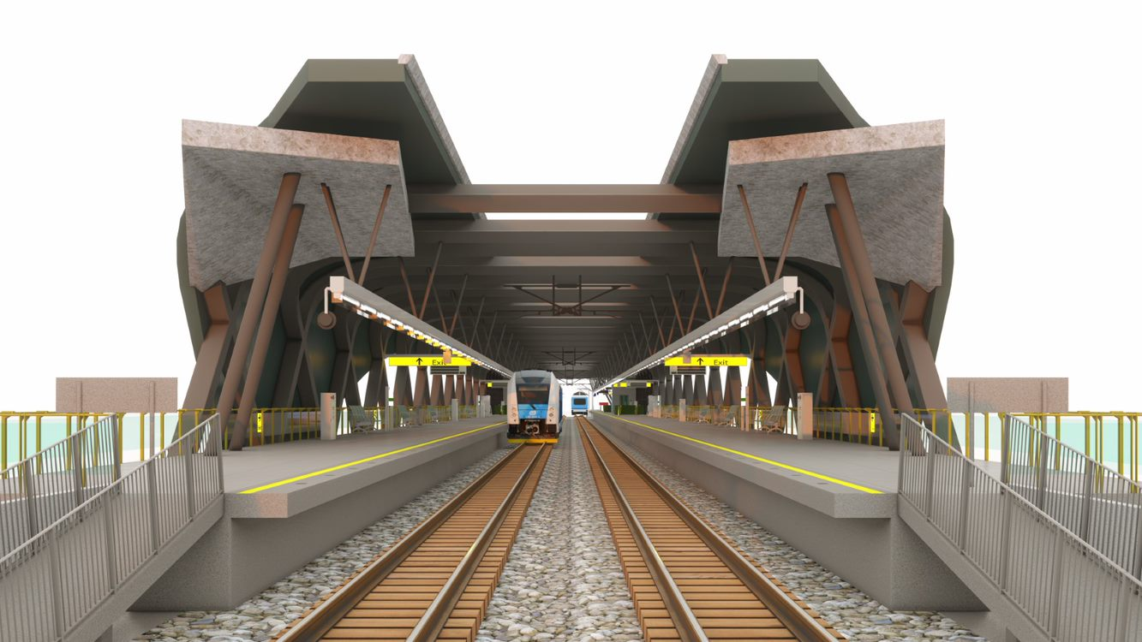
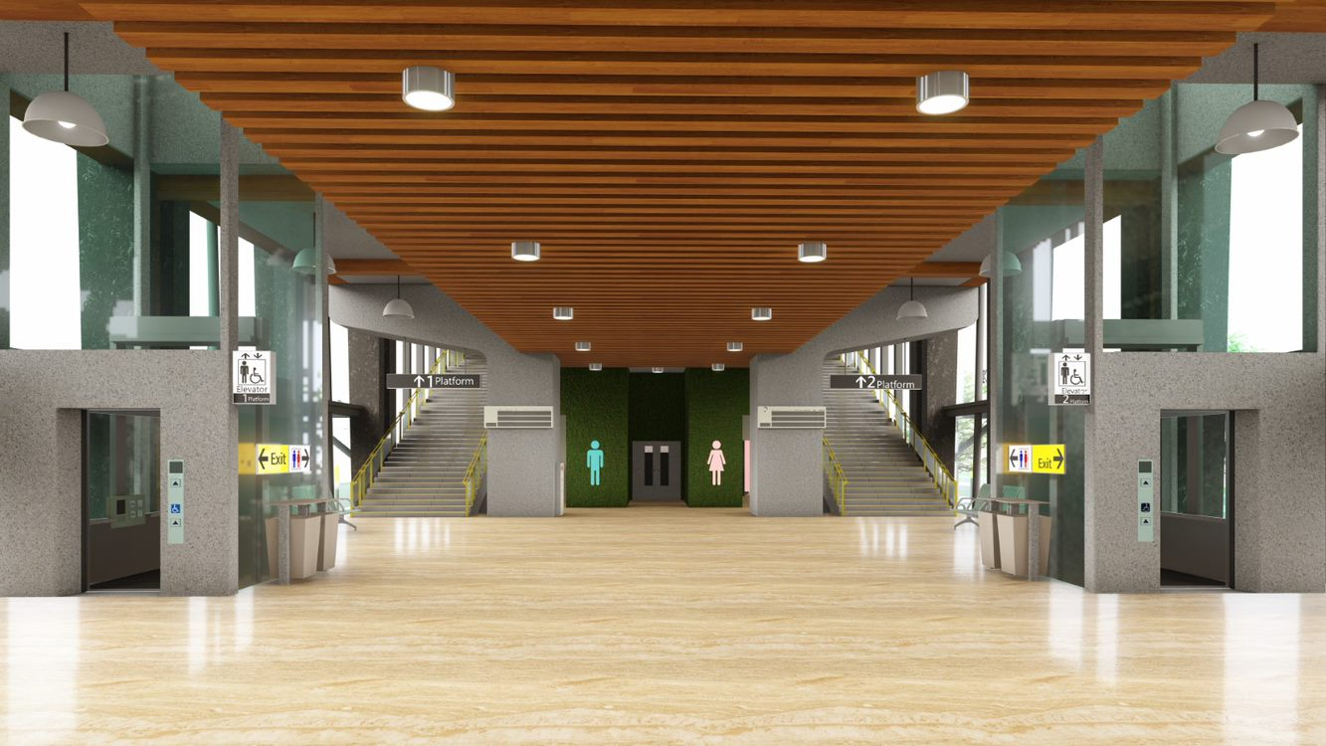
Client Summary
The metro station project in USA was designed by Tejjy Inc. with a total build-up area of 70,000 sq. ft. and aims in creating an exceptional transit experience for the users. Synchronized parking, pedestrian-friendly areas, and striking landscaping are features of the metro station. Located on a busy street, the design of a public transit station was a challenging endeavor.
Scope and Deliverables
Tejjy Inc. was responsible for creating the LOD 350 3D BIM model for architectural and structural services of the metro station in USA. We also provided shop drawings, rebar detailing, and architectural visualization services.

Our main responsibilities are:
- LOD 350 architectural and structural BIM model
- Architectural visualization and 3D rendering
- Architectural and structural shop drawings
- Clash detection and BIM coordination
- 5D BIM Quantity Take Off (QTO) and Bill of Quantities (BOQ)
- Walkthrough video
- 4D BIM scheduling video simulation

As the new metro station will be built in the middle of a busy street, the scope of work included many restricted scenarios and site limitations. Construction planning and management were challenging because of the metro station's complicated construction on a short schedule, as well as resource allocation and coordination issues under the control of dozens of subcontractors.

Challenges
Tejjy realized that the conventional methods of design, manufacture, and construction management would only inevitably increase the overall difficulties of the work, as well as the costs. A large amount of BIM clash detection and coordination was required. The project’s requirement suited the integration of BIM project management tools like 4D BIM and 5D BIM.
Facility management was intended from the start to preserve all construction details for metro station maintenance. While the short timeframe and sheer size of this project posed numerous difficulties, Tejjy faced other challenges, including the structural design and rebar detailing of this large-span structure.
Solutions
- Achieving 4D and 5D BIM integration
As we realized a large and complex project like this should be completed on time and within the prescribed budget, we provided an integrated project simulation video by linking the 3D BIM model, with schedule and cost with the help of Synchro software. Using simulation, contractors can identify and fix problematic construction sequences in a timely manner. Model-based construction progress monitoring and budgeting during execution helped in efficient construction management.
- Facility Management with As-Built BIM Model
The metro station has to serve the public for the decades to come. Efficient management of the metro facility can save maintenance costs and improve infrastructure operations. For that, we created an as-built model for facility management. This also helps in asset management to maximize project lifecycle value. Our as-built BIM model implementation helped in minimizing operations costs and risks involved.
- BIM for Architectural Visualization
We ensured that getting our design approved by our clients was an easy task. For that we used BIM software like Autodesk Revit to create models and rendering software like Unreal Engine is used to create presentation walkthroughs and images. Architectural visualizations and 3D renderings ensured that every stakeholder could visualize the project before the start of construction. Visualization during preconstruction enabled the reduction of costly errors during construction.
- Clash Detection and BIM Coordination
While creating the BIM model, our MEP engineers came across clashes with the structural components of the building. We employed Navisworks software to detect 1500+ clashes. We fixed these clashes by adjusting the mechanical/HVAC, electrical, plumbing, and fire protection services in accordance with the metro station’s beams and columns. We used Autodesk Revit to fix these clashes efficiently.
- Automating Design Tasks with Dynamo
There are various time-consuming repetitive tasks during the design process. We could cut down the time and money in designing with the help of Dynamo’s BIM automation. The large span beams and columns can be designed accurately with the help of this process. This has helped the architects and engineers of our team to get away with tedious tasks.
- Efficient Rebar Detailing with BIM Software
Structural BIM software named Tekla Structures is used for accurate and detailed rebar detailing and the creation of structural shop drawings. Tejjy employed Tekla Structures to create a model for rebar details, which allowed for more efficient steel processing and fabrication. Detailed structural analysis by BIM helped in making efficient decisions about structural design. All the risks related to structural stability were easily calculated, and appropriate design decisions were made.
Production operations that were once done manually are now automated by the BIM, which uses data extracted from the BIM model to create an intelligent plant-based environment for manufacturing and installation.

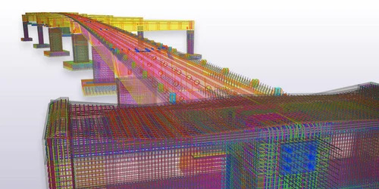
Values Delivered
BIM enabled efficient and optimized workflow, reduction in execution cost, and ability to make precise decisions. Navisworks clash detection and coordination helped in fixing 1500+ clashes by downsizing and rerouting services, which includes 300+ significant clashes.
Daily meeting attendance was created using Navisworks software for the purpose of resolving clashes and disagreements and incorporating responses to RFIs. Plans, sections, shop drawings, and other necessary information for MEP FP (Mechanical/HVAC, Electrical, Plumbing, and Fire Protection) services were provided.
Analysis based on 3D BIM models performed from concept through commissioning helped in the smooth completion of the project. 4D and 5D BIM helped in controlling and monitoring the progress of the project efficiently. As-built model for efficient facility and asset management helps metro station facility manager to manage and maintain the facility despite the rush of passengers and metro trains.
Final Thoughts and Road Ahead
Implementation of different BIM software for different types of solutions has enabled us to get the best output. Revit for modeling, Synchro for 4D and 5D BIM, Navisworks for clash detection, and Tekla Structures for rebar detailing and structural design have collectively helped to make the design of this metro station near perfection.
After the completion of the project, we understood the importance of implementing BIM automation to find design options and save design time. We plan to implement BIM automation in all of our future projects.
Project Summary
Project Name | Metro Station Project
Project Type | Transport Infrastructure
Trades Covered | Architectural BIM, Structural BIM
Scope of Work | Shop drawings, Architectural Visualization, Clash Detection, BIM Coordination, rebar Detailing
LOD | 350
Average BIM Team Size | 25
Software Applications Used  for the Project | Autodesk Revit, Unreal Engine, Navisworks, Tekla Structures, Synchro

